**Enterprise Resource Planning**

**Training User Manual**

**VERSION 12.0.0**

**Sales & Invoice**

# Sales & Invoice

**Options**

1. [Invoice Entry](http://192.168.1.17:8090/zab/login?screen=opdoheader&option=Invoice+Entry&menuname=op)
2. [Sales Return](http://192.168.1.17:8090/zab/login?screen=opcrnheader&option=Sales+Return&menuname=op)
3. [Warranty Claim](javascript:run1()&menuname=opclaim)
4. [Quotation](http://192.168.1.17:8080/zab/login?screen=opquotheader&option=Quotation&menuname=op)
5. Reports

# [Invoice Entry](http://192.168.1.17:8090/zab/login?screen=opdoheader&option=Invoice+Entry&menuname=op)

## Invoice Header

|  |  |
| --- | --- |
| **Step 1** | Open System **>** Sales & Invoice **>** Invoice Entry |
| **Step 2** | Select Customer Number from list, payment type etc. |
| **Step 3** | Click Add |
| **Result** | New Invoice header created |

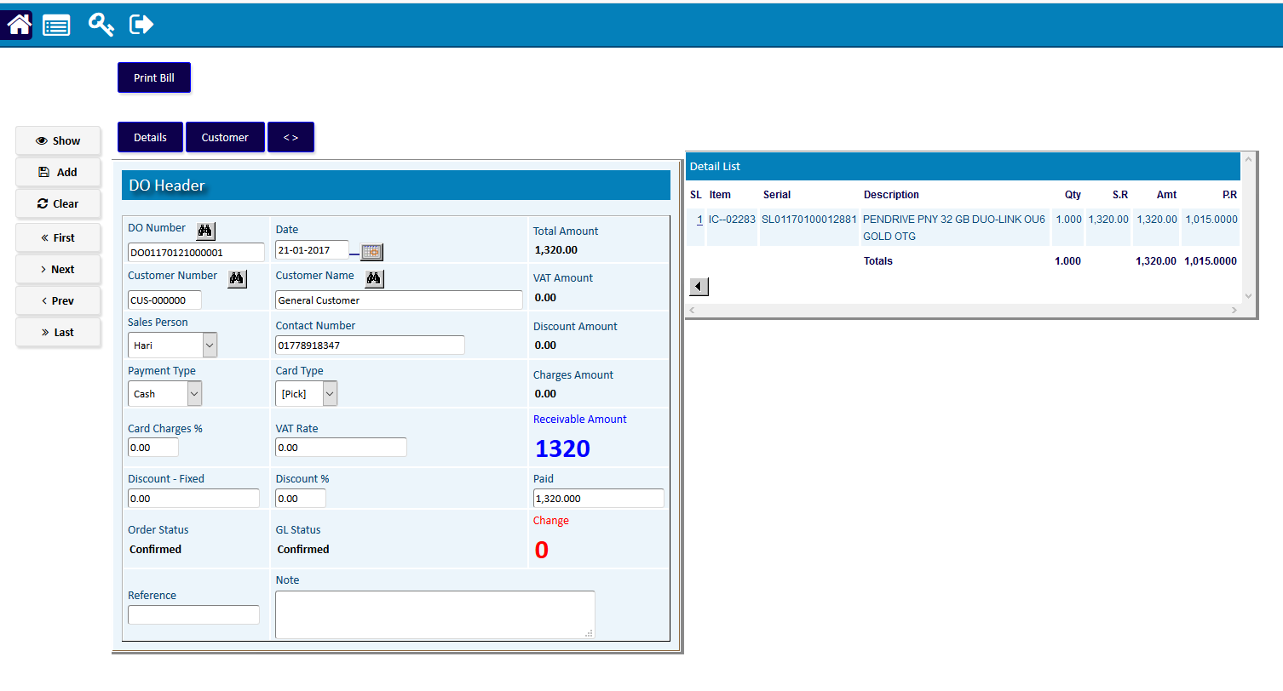

## Invoice Detail

|  |  |
| --- | --- |
| **Step 1** | Click Detail |
| **Step 2** | Click Detail for selecting Products for sale |
| **Step 3** | Select Product code, Required Quantity |
| **Step 4** | Click Add |
| **Step 5** | Repeat Step 1 to 3 for adding multiple products |
| **Step 6** | Click **Return** to return to Invoice header |
| **Step 8** | Click **Confirm** to confirm the Invoice. |
| **Note** | Invoice cannot be changed after confirmation. |
| **Result** | Invoice creation complete |

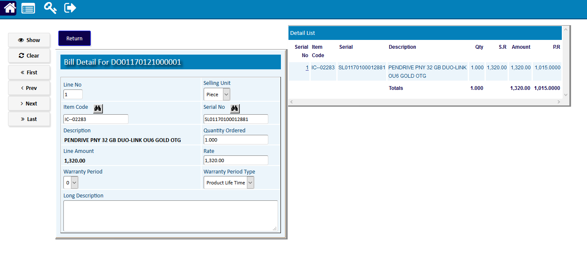

Click on **‘Print Bill’** button to print the completed Invoice.

# [Sales Return](http://192.168.1.17:8090/zab/login?screen=opcrnheader&option=Sales+Return&menuname=op)

## Sales Return Header

|  |  |  |
| --- | --- | --- |
| **Step 1** |  | Open System **>** Sales & Invoice **>** Sales Return |
| **Step 2** |  | Select Store Invoice (DO) no. |
| **Step 3** |  | Click **Add** |
| **Step 4** |  | Click **Print Return** for preview in print format. |
| **Result** |  | New Sales Return entry |

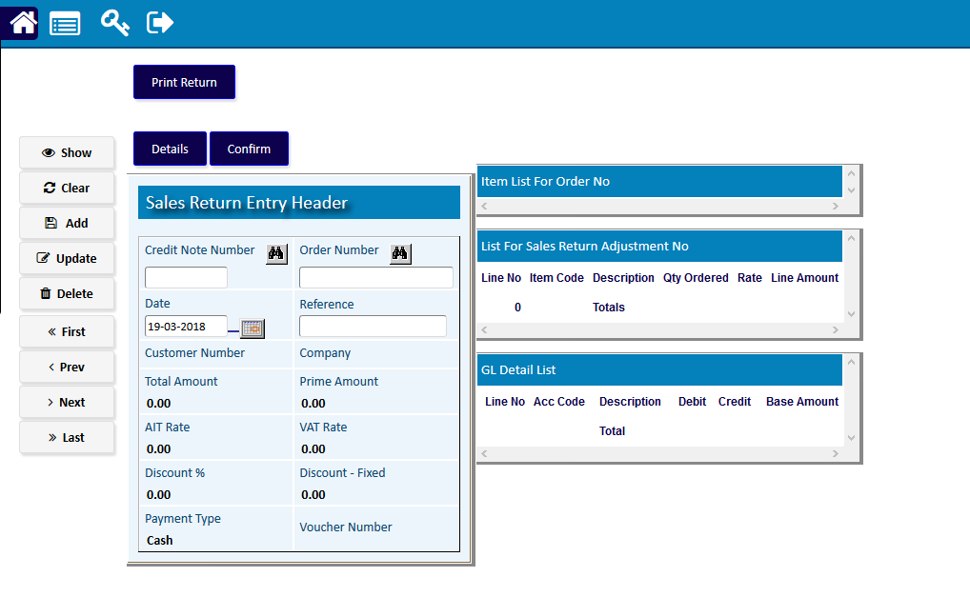

## Sales Return Detail

|  |  |
| --- | --- |
| **Step 1** | Click Detail |
| **Step 2** | Select Product code, Required Quantity |
| **Step 3** | Click Add |
| **Step 4** | Repeat Step 1 to 3 for adding multiple products |
| **Step 5** | Click **Return** to return to SR header |
| **Step 6** | Click **Confirm** to confirm the SR. |
| **Note** | SR cannot be changed after confirmation. |
| **Result** | SR creation complete |

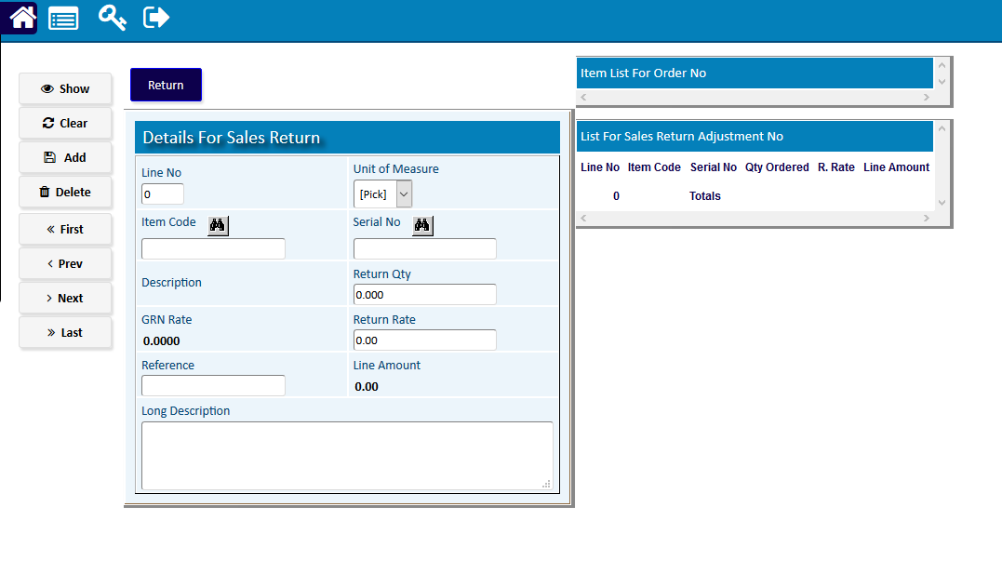

# Warranty Claim

## Warranty Claim Header

|  |  |  |  |  |
| --- | --- | --- | --- | --- |
| **Step 1** |  |  |  | Open System **>** Sales & Invoice **>** Warranty Claim |
| **Step 2** |  |  |  | Select serial no of the product. |
| **Step 3** |  |  |  | Click **Add** |
| **Step 4** |  |  |  | Click **Print Claim** to preview in print format. |
| **Result** |  |  |  | New claim created. |

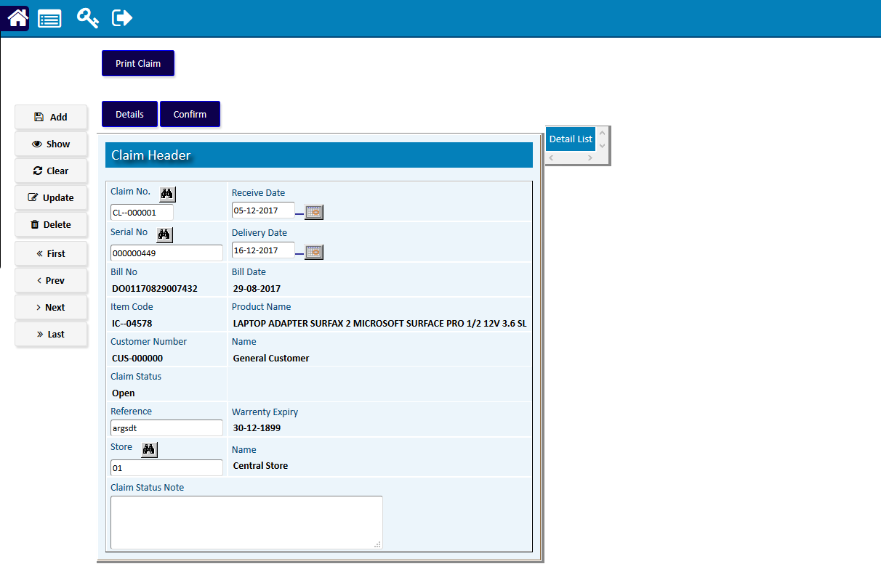

## Warranty Claim Detail

|  |  |
| --- | --- |
| **Step 1** | Click Detail |
| **Step 2** | Select Type of Claim, Product code, Serial Number |
| **Step 3** | Click **Add** |
| **Step 4** | Repeat Step 2 for adding multiple Issue Types |
| **Step 5** | Click **Return** to return to Claim header |
| **Step 6** | Click **Confirm** to confirm the Claim. |
| **Note** | Claim cannot be changed after confirmation. |
| **Result** | Claim creation complete |

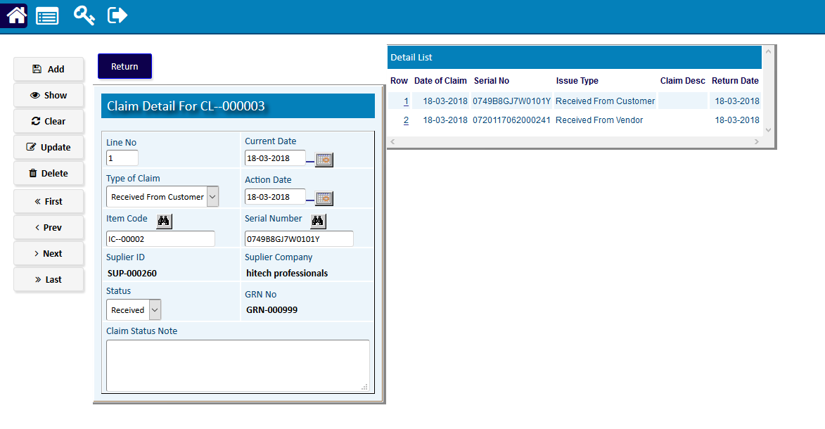

# [Quotation](http://192.168.1.17:8090/zab/login?screen=opcrnheader&option=Sales+Return&menuname=op) Entry

|  |  |
| --- | --- |
| **Step 1** | Open System **>** Sales & Invoice **>** Quotation Entry |
| **Step 2** | Select PR from side list or write the no in the PR no field |
| **Step 3** | Click show |
| **Step 4** | Click Detail |
| **Step 5** | Select the desired Item from the Requisition Detail side list |
| **Step 6** | Click Quotation Entry |
| **Step 7** | Select specification, fill in the value for the specification in Quotation 1,2,3,4,5. |
| **Step 8** | Click Add |
| **Step 9** | Repeat Step 5 to 7 for adding multiple specification |
| **Result** | Quotation filled for Comparison Statement |

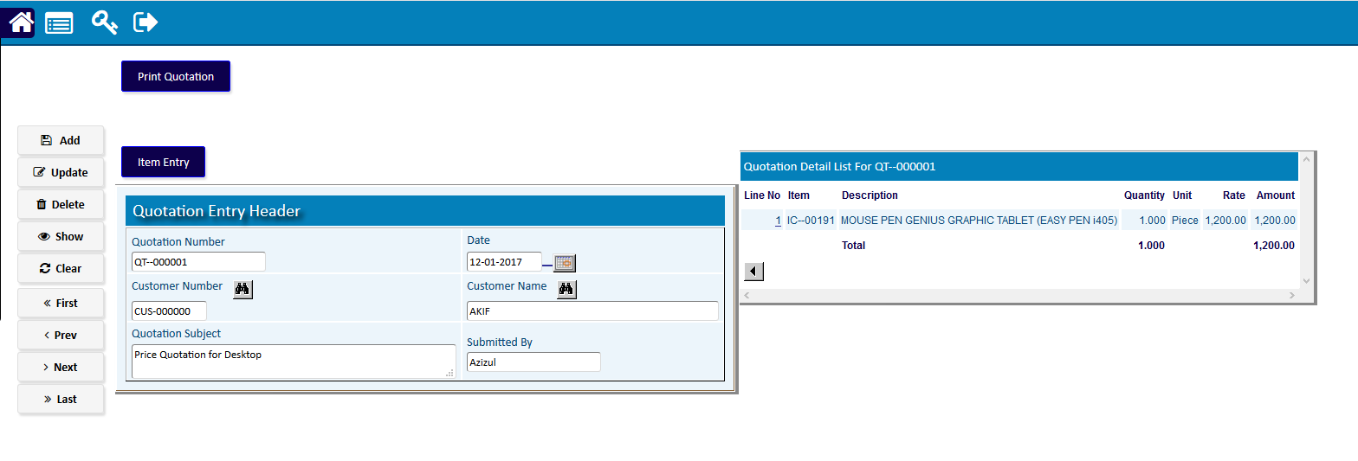

# Reports

## Printing report to preview data

|  |  |  |  |
| --- | --- | --- | --- |
| **Step 1** |  |  | Open System **>** Sales & Invoice **>** Reports |
| **Step 2** |  |  | Select a report option. |
| **Step 3** |  |  | Select the start date, end date & other fields to specify data previewing in the report. |
| **Step 4** |  |  | Click **“View Report”** to preview in print format. |
| **Result** |  |  | The report is previewed in print format. |

